BI Insights Project- Part 1
Group 5
Ismail Ismail n01720388
Jay Yatin Vora n01697058
Tejas Samanthapudi n01689933
Rajkumar Ramu n01705840
Garvit Singh n01684893
Introduction
Industry: Healthcare
Company Description:
PureMed Solutions is a healthcare organisation dedicated to providing holistic, patient-centred care in a number of environments, such as clinics and hospitals. The organisation is dedicated to optimising patient outcomes, optimising its entire operational process, and improving diagnostics. PureMed Solutions is facing challenges in resource management, diagnostic accuracy, and getting the most efficient use of medical staff and equipment due to an increasing patient base. The business applies data analytics to find obstacles to operations, streamline processes, and better allocate resources in order to address these problems. PureMed Solutions seeks to improve both the standard of care and the effectiveness of its operations. Additionally, the business strives to increase patient satisfaction by reducing wait times and customising treatment regimens via data-driven decision-making. The goal of PureMed Solutions' innovations is to provide healthcare services that are more efficient.
Problem
Data overload: Often called information overload, data overload occurs when individuals or organisations are faced with an excessive amount of data, making it difficult to process, analyse, and extract useful insights. This overwhelming volume can lead to confusion and inefficiency, hindering effective decision-making and negatively affecting both day-to-day operations and long-term strategic planning. As a result, organisations may struggle to identify key trends, make informed choices, and ultimately achieve their goals.
How analytics will be used to address this problem
To tackle data overload using analytics, organisations should take a clear and focused approach. First, it's important to set specific goals and identify key performance indicators (KPIs) that align with those goals, so that data collection is relevant. Using filtering techniques can help narrow down data to the most important information, while data aggregation and visualisation tools can turn complex datasets into easy-to-understand summaries on dashboards. Advanced analytics, such as machine learning, can automate the detection of trends and outliers, making it easier to find useful insights without getting lost in too much information. Establishing clear data governance helps maintain quality and ensures that unnecessary data is removed. Additionally, providing training to improve data skills among employees empowers them to make better decisions based on the insights available. By using these strategies, organisations can manage data overload effectively, turning what could be an overwhelming amount of information into clear, actionable insights that support better decision-making and improve efficiency.

Analytics Questions

Question 1:
How many patients are treated on average per day in each clinic or hospital location?
Type of Analytics: Descriptive Analytics
How the answer helps solve the problem: This question helps identify patient traffic across different locations, providing insights into which facilities may be over- or under-utilised. Understanding patient volume patterns is critical to managing resources and staff efficiently.
Prediction Requirements: Historical patient data across locations.
Business Decisions Based on Insights: Decisions can be made to better allocate medical staff, adjust operating hours, or plan expansions for locations handling higher volumes of patients.

Question 2:
What is the patient satisfaction rate across different services or locations?
Type of Analytics: Descriptive Analytics
How the answer helps solve the problem: This allows the organisation to gauge the success of their patient care efforts and pinpoint areas for improvement. High patient satisfaction is often linked to better operational efficiency and care quality.
Prediction Requirements: Patient surveys, feedback forms, or social media sentiment analysis.
Business Decisions Based on Insights: Improve patient care protocols, adjust staff training, or address specific areas where patient satisfaction is low.

Question 3:
Is there a risk of data loss due to overload?
Type of analytics: Diagnostic Analytics
How the answer helps solve the problem: Identifying potential risks allows for proactive measures to safeguard data.
Prediction requirements: Risk assessments based on current data loads and backup strategies.
Business decisions based on insights: Invest in robust backup solutions and disaster recovery plans to mitigate risks.

Question 4:
Is the distribution of data properly done?
Type of analytics: Diagnostic Analytics
How the answer helps solve the problem: distributing data properly means organising the data so that we know which is important and which is not, that way we can find the information we are looking for more easily and avoid data overload.
Prediction requirements: Overseeing databases on a frequent basis.
Business decisions based on insights: Having skilled personnel for data distribution and overseeing the distributed work.

Question 5:
Is managing data using new tools done properly?
Type of analytics: Diagnostic Analytics
How the answer helps solve the problem: New technologies and tools alway emerge, so it is important to update and adapt to be more efficient and effective but it is also important to know how to properly use the new tools for benefits, since using something you are not experienced with can cause problems in this case it is data overload.
Prediction requirements: Assess work experience of the data management team and find if anyone is finding it difficult to use the new tool.
Business decisions based on insights: Invest in worker training programs or find some highly skilled workers for the role.

Question 6:
Which patients are most likely to experience prolonged hospital stays or complications, based on their medical history and current health indicators?
Type of analytics: Predictive Analysis
How the answer helps solve the problem: By identifying high-risk patients in advance, PureMed Solutions can allocate resources more effectively, such as assigning specialised staff or additional monitoring to prevent complications. It also aids in optimising bed and staff management, improving overall operational efficiency.
Prediction requirements: Patient medical history, current health indicator, treatment plans and historical data.
Business decisions based on insights: PureMed Solutions can make informed decisions to optimise resource allocation, adjust staffing, and implement preventive care strategies for high-risk patients based on predictive insights.

Question 7:
Which specific processes could PureMed Solutions streamline or automate to lower operational costs and improve patient care quality, while taking into account key performance indicators and limited resources?
Type of analytics: Prescriptive Analysis
How the answer helps solve the problem: Answering this question helps PureMed Solutions manage data overload and make operations smoother by pointing out exactly which processes to improve. By choosing specific tasks to streamline or automate, PureMed can focus on the most important areas, using resources more wisely.By linking process improvements to key performance indicators (KPIs), PureMed can also see how these changes make a difference. This makes it easier to track progress and ensure each change helps them reach their goals.
Prediction requirements: Systems to monitor prediction accuracy over time and collect feedback, enabling model updates and adjustments to improve accuracy.
Business decisions based on insights: Predicting supply needs and usage trends enables PureMed to streamline inventory management, minimising waste and reducing unnecessary expenses.Key performance indicators that align with organisational goals (e.g., patient satisfaction scores, average wait times, treatment accuracy rates) provide measurable outcomes for validating prediction accuracy.

Data Entities
Patient
Description: The Patient entity records information about individuals receiving care from healthcare providers. It is foundational to the healthcare system, as all services and records revolve around patient information.
Attributes:
- Patient ID: A unique identifier assigned to each patient within the healthcare system, used to ensure accurate tracking of patient records, appointments, and treatments. This primary key helps maintain data integrity and facilitates relationships with other entities, such as appointments, treatments, and payments.
- FirstName: The patient's given name, used to identify the individual in a personal and formal context.
- LastName: The patient's family name or surname, essential for distinguishing between patients with similar first names.
- DOB (Date of Birth): The patient's birthdate, important for age verification, medical history, and eligibility for certain treatments.
- PhoneNumber: The patient's contact number, used for communication regarding appointments, test results, and follow-up care.
Doctor
Description: The Doctor entity captures information about the healthcare providers delivering care to patients. This entity is vital for coordinating care, ensuring qualified professionals are involved in treatment, and tracking provider performance.
Attributes:
- DoctorID: A unique identifier assigned to each doctor within the healthcare system, used to track their records, specialties, and associated appointments. This primary key ensures data integrity and facilitates relationships with other entities, such as patient appointments, treatments, and prescriptions.
- Patient ID (foreign ID): A unique identifier for the patient, which may reference a primary key from a related entity (such as a Patient table) to establish a relationship between entities.
- FirstName: The patient's given name, used for identification and personal interaction.
- LastName: The patient's family name or surname, important for distinguishing between patients.
- Specialty: The area of medical expertise relevant to the patient’s care, often used to identify the type of healthcare provider or treatment needed.
- PhoneNumber: The patient's contact number for communication regarding appointments, test results, and other important information.
Appointment
Description: The Appointment entity captures details of scheduled visits between patients and healthcare providers. It is essential for managing patient flow and ensuring timely care, helping to optimise scheduling and reduce wait times.
Attributes:
- Appointment ID: A unique identifier assigned to each appointment within the healthcare system, used to track scheduling, patient visits, and associated treatments. This primary key ensures data integrity and facilitates relationships with other entities, such as patients, doctors, and test results.
- PatientID (Foreign Key): A unique identifier that references the Patient entity, linking the appointment to a specific patient.
- DoctorID (Foreign Key): A unique identifier that references the Doctor entity, associating the appointment with a specific healthcare provider.
- AppointmentDate: The date and time when the appointment is scheduled, important for managing scheduling and patient flow.
- Status: The current state of the appointment (e.g., scheduled, completed, cancelled), which helps track appointment management and follow-up actions.
Treatment
Description: The Treatment entity outlines the medical procedures and interventions provided to patients. It is vital for tracking patient care and outcomes, helping providers ensure that patients receive appropriate and effective treatments.
Attributes:
- Treatment ID: A unique identifier assigned to each treatment provided within the healthcare system, used to track specific procedures, medications, and associated patient care. This primary key ensures data integrity and facilitates relationships with other entities, such as appointments, patients, and billing records.
- AppointmentID (Foreign Key): A unique identifier that references the Appointment entity, linking the treatment to a specific appointment.
- TreatmentType: The specific type of treatment or procedure provided during the appointment, essential for medical records and billing.
- Cost: The total charge associated with the treatment, important for billing purposes and financial records.
- Notes: Additional comments or observations related to the treatment, which can include details about the procedure, patient response, or follow-up recommendations.
Billing
Description: The Billing entity manages financial transactions related to patient care, including charges for services, payments received, and outstanding balances. It plays a crucial role in ensuring that healthcare providers are compensated for their services, thus maintaining the financial viability of the medical practice.
Attributes:
- Billing ID: A unique identifier assigned to each billing record within the healthcare system, used to track financial transactions, payments, and associated services rendered. This primary key ensures data integrity and facilitates relationships with other entities, such as patients, treatments, and payments.
- PatientID (Foreign Key): A unique identifier that references the Patient entity, linking the payment to a specific patient.
- Amount: The total sum paid for services rendered, important for financial tracking and billing records.
- PaymentDate: The date when the payment was made, crucial for accounting and managing payment timelines.
- Status: The current state of the payment (e.g., completed, pending, refunded), which helps in tracking payment processing and follow-up actions.
LabTest
Description: The Lab Test entity documents various laboratory tests ordered for patients. It is important for diagnosing conditions, monitoring health, and guiding treatment decisions, playing a vital role in patient care.
Attributes:
- Test ID: A unique identifier assigned to each test conducted within the healthcare system, used to track specific diagnostic procedures and their results. This primary key ensures data integrity and facilitates relationships with other entities, such as patients, appointments, and medical records.
- AppointmentID (Foreign Key): A unique identifier that references the Appointment entity, linking the test to a specific appointment.
- EquipmentID (Foreign Key): A unique identifier that references the Equipment entity, associating the test with the specific equipment used for the procedure.
- TestType: The specific kind of test conducted (e.g., blood test, imaging), important for medical records and treatment plans.
- TestResult: The outcome or findings of the test, essential for diagnosis, treatment decisions, and patient records.
Prescription
Description: The Prescription entity tracks medications prescribed to patients. It is essential for ensuring that patients receive the correct medications, enhancing safety and adherence to treatment plans.
Attributes:
- Prescription ID: A unique identifier assigned to each prescription issued within the healthcare system, used to track medications prescribed to patients, dosage instructions, and refills. This primary key ensures data integrity and facilitates relationships with other entities, such as patients, doctors, and billing records.
- Appointment ID (Foreign Key): A unique identifier that references the Appointment entity, linking the medication to a specific appointment.
- Medication: The name of the prescribed medication, essential for tracking treatment plans and patient care.
- Dosage: The specific amount of the medication to be administered, crucial for ensuring proper treatment and safety.
- Frequency: The recommended intervals at which the medication should be taken (e.g., once daily, twice a week), important for adherence to the treatment regimen.
Visit Summary
Description: The Visit Summary entity provides a comprehensive overview of each patient visit, including notes from the healthcare provider and any recommendations made. It is crucial for continuity of care and helps in making informed decisions during future visits.

Attributes:
- Summary ID: A unique identifier assigned to each visit summary record within the healthcare system, used to track detailed notes and observations from patient visits. This primary key ensures data integrity and facilitates relationships with other entities, such as patients, appointments, and medical histories.
- AppointmentID (Foreign Key): A unique identifier that references the Appointment entity, linking the visit notes to a specific appointment.
- VisitNotes: Detailed observations and comments recorded by the healthcare provider during the patient’s visit, important for ongoing patient care and medical history.
- FollowUpRequired (Yes/No): A flag indicating whether a follow-up appointment or action is necessary based on the visit, helping in care continuity.
- FollowUpDate: The scheduled date for the follow-up, if required, which aids in managing patient appointments and ensuring timely care.
HR_Staff
Description: The HR Staff entity encompasses human resources personnel involved in managing medical staff, including hiring, training, and compliance. This entity is critical for maintaining a skilled workforce and ensuring quality patient care.
Attributes:
- Staff ID: A unique identifier assigned to each staff member within the organization, used to track their records, roles, and responsibilities. This primary key ensures data integrity and facilitates relationships with other entities, such as HR records, issue tracking, and departmental assignments.
- FirstName: The given name of the HR staff member, used for identification and personal interaction.
- LastName: The family name or surname of the HR staff member, important for distinguishing between individuals.
- Position: The specific job title or role of the HR staff member within the organisation, indicating their responsibilities and level of authority.
- HireDate: The date when the HR staff member was hired, important for tracking employment duration, benefits eligibility, and organisational history.
Tech Support
Description: The Tech Support entity represents the personnel responsible for managing and troubleshooting technology systems within the healthcare facility. Their role is crucial for ensuring that electronic health records and other tech resources operate smoothly.
Attributes:
- Support ID: A unique identifier assigned to each support ticket or request within the healthcare system, used to track issues or inquiries raised by patients or staff. This primary key ensures data integrity and facilitates relationships with other entities, such as staff members, issue resolutions, and communication records.
- StaffID (Foreign Key): A unique identifier that references the Staff entity, linking the reported issue to a specific HR staff member.
- IssueDescription: A detailed account of the issue or concern being reported, essential for understanding the context and nature of the problem.
- DateReported: The date when the issue was reported, important for tracking the timeline of the resolution process.
- ResolutionStatus: The current state of the issue (e.g., open, in progress, resolved), which helps in managing follow-ups and ensuring accountability in issue resolution.

Entity Relationship Diagram(ERD):
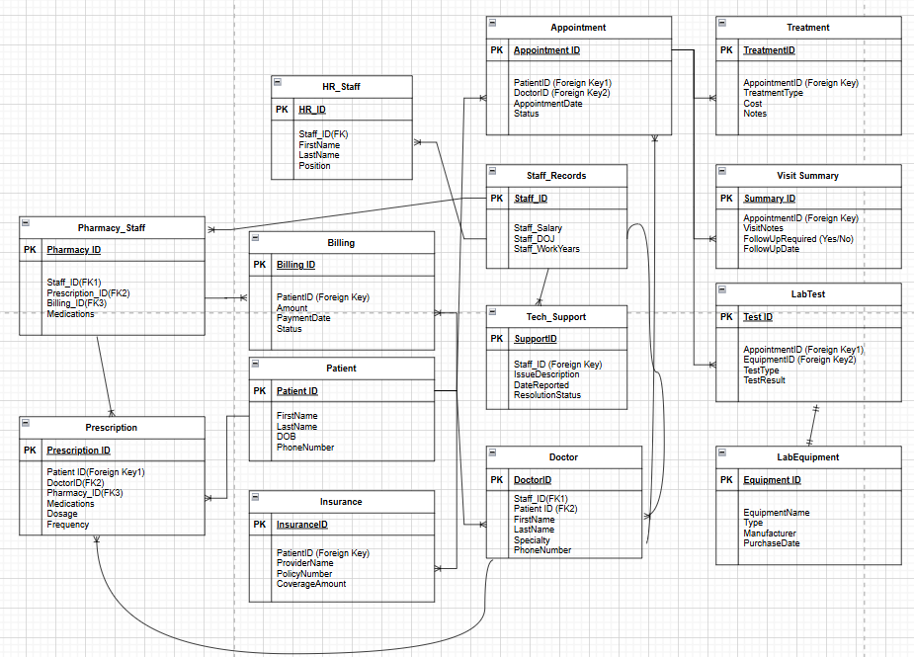

Systems of Record

System of Record 1: Medical Health Records
Main Users: Health information officer, Doctors, Nurses, Data analyst and other healthcare providers.
Purpose and reason of importance: Records of patient’s medical history, treatments gone through, medications and prescriptions, lab results. And if we don't have the data about the patient's history and records, we can’t proceed further with our own treatment plans.
Main Sources of Data: Patient Medical Check ups and Reports
Data Entities Maintained:
- Patient
- Doctor
- Treatment
- Prescription
- LabTest

System of Record 2: Patient Track Records
Main Users: Health information officer, Doctors, Nurses, IT support and Administrator.
Purpose and reason of importance: This tracks patient appointments, scheduling, and billing information. And this system helps tracking the customer behaviour and understanding the health market.
Main Sources of Data: Patient entry information system.
Data Entities Maintained:
- Patient
- Appointment
- Visit Summary
- Billing

System of Record 3: Results and Reports
Main Users: Health information manager, laboratory manager, IT support, Quality Analyst.
Purpose: This manages lab tests and results, including tracking samples and reporting findings. And this system helps doctors make important decisions about a patient's health condition.
Main Sources of Data: System or Equipment readings, Former Patient Reports and New lab results.
Data Entities Maintained:
- Patient
- Doctor
- LabTest
- Treatment

System of Record 4: Medical Prescription Records
Main Users: Pharmacy manager, Pharmacist, Health information manager, IT support, Quality Analyst.
Purpose: This records medication prescriptions, inventory, and dispensing information. And it helps pharmacies as well as doctors to keep the track of medicines and drug outflow.
Main Sources of Data: Prescription papers signed by Chief Doctor.
Data Entities Maintained:
- Patient
- Doctor
- Prescription

System of Record 5: Billing Records
Main Users: Billing manager, Finance officer, Revenue Analyst, IT support, medical coder.
Purpose: This system tracks patient billing, insurance claims, and payment processing. And it helps the medical centre to keep track of the financial situations and revenue productions.
Main Sources of Data: Patient Registration data, patient Reports, Prescription bills, insurance information.
Data Entities Maintained:
- Patient
- Insurance
- Billing

System of Record 6: Human Resources Management System
Main Users: HR manager, HR generalist and specialist, payroll manager.
Purpose: This manages employee records, payroll, and staffing information for the healthcare staff. It helps to keep track of the employee status of work and their wages.
Main Sources of Data: Employee records, Employee Paycheck list.
Data Entities Maintained:
- Staff_Records

System of Record 7: General Resource Management Systems
Main Users: Pharmacy staff, Nurses, Doctors, IT support and Supply chain Managers.
Purpose: Tools for tracking medical supplies, equipment, and pharmaceuticals to ensure availability and compliance. It helps in keeping track of all the necessary resources which need to be present in stock and in good condition.
Main Sources of Data: Vendors, Sellers, Inventory manager, Partners.
Data Entities Maintained:
- LabEquipments
- Pharmacy_Staff
- Tech_Support

Context Model
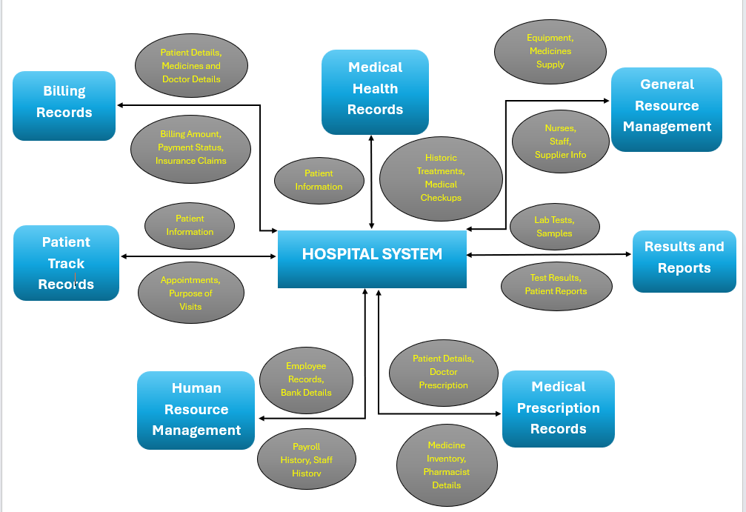

Data Preparation and Data Wrangling Activities

Activity 1: Data Cleansing
- Goal: To remove outdated or low-value records that may contribute to data overload, ensuring only relevant, active patient data is retained.
  - Impacted Data Entities: Patient, Appointment.
  - Source System: Patient Track Records.
  - Anticipated Issues: Excessive inactive patient records, particularly those with common names who haven't checked in recently, may clutter the data and hinder efficient analysis. Also, could lead to human error in diagnosis and contacting patients within the system.
- Examples:
  - Before Cleansing:
    - Patient Table: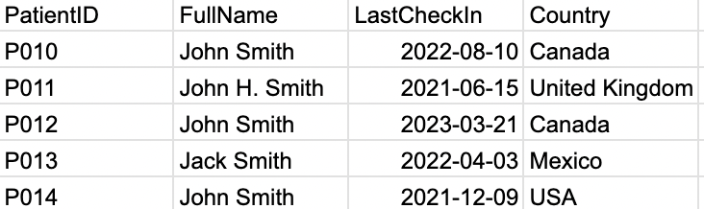
    - Appointment Table:
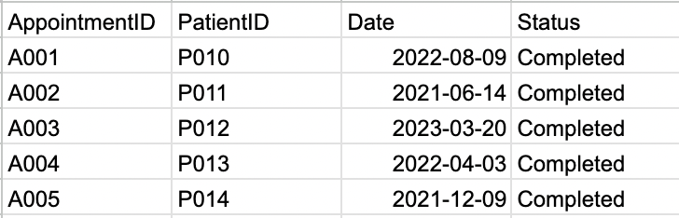
  - After Cleansing (removed inactive patients with common names outside the main country):
    - Patient Table: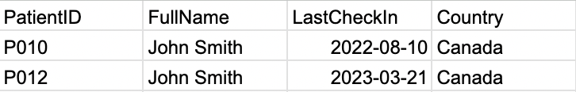
    - Appointment Table: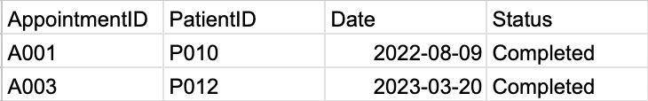

Explanation: Certain patients named "John Smith" who were not from Canada and hadn’t checked in for over a year were removed. This reduced data clutter by excluding irrelevant records, ensuring that the analysis reflects only current, relevant patient data.

Activity 2: Data Profiling
- Goal: To assess data quality by analysing patterns, distributions, and inconsistencies.
  - Impacted Data Entities: Prescription, Patient, LabTest.
  - Source Systems: Medical Health Records, Results and Reports.
  - Anticipated Issues: Data profiling will identify incomplete records, duplicate entries, or missing attributes. For example, prescriptions without dosage information or lab tests without results will be flagged for correction.
- Examples:
  - Before Profiling:
    - Prescription Table: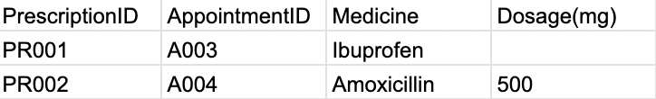
    - LabTest Table: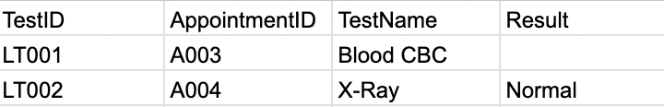
  - After Profiling:
    - Prescription Table: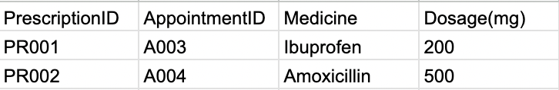
    - LabTest Table: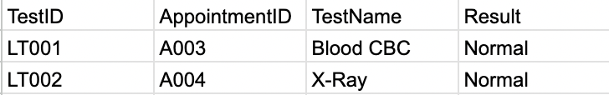
Explanation: Missing dosages in the Prescription Table were flagged and filled in where necessary. This profiling step ensured that medication records were complete, improving the reliability of prescription data and supporting safe, accurate tracking of treatments.

Activity 3: Data Enrichment
- Goal: To add valuable context to existing data by integrating external or supplementary information, providing a more complete picture for analysis.
  - Impacted Data Entities: Patient, Doctor.
  - Source Systems: Medical Health Records, Human Resources Management System.
  - Anticipated Issues: A lack of contextual information (e.g., patient lifestyle factors, doctor certifications) might limit analysis accuracy. By enriching records with this additional data, the company can develop more detailed insights.
- Examples:
  - Before Enrichment:
    - Doctor Table: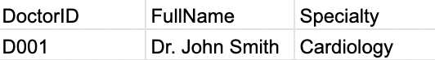
    - Patient Table:
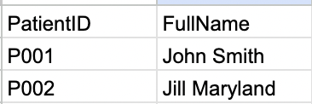
  - After Enrichment:
    - Doctor Table:
    - Patient Table: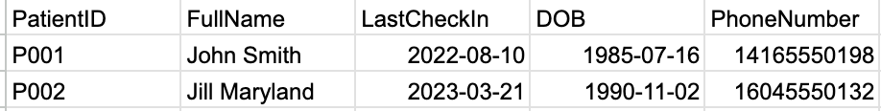
Explanation: Enrichment added additional context to doctor and patient records, such as experience and certification status for doctors, and phone numbers and dates of birth (DOB) for patients. These details provided a fuller profile for both patients and doctors, improving the quality of risk assessments and patient care insights.

Activity 4: Data Transformation
- Goal: To standardise and reformat data to improve consistency and facilitate analysis.
  - Impacted Data Entities: Billing, Treatment, LabEquipment.
  - Source System: Billing Records, Results and Reports.
  - Anticipated Issues: Issues like inconsistent formats for dates, measurements, or statuses can impede analysis. Standardising these formats ensures consistency, enabling better data comparison and aggregation.
- Examples:
  - Before Transformation:
    - Billing Table: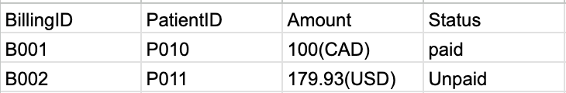
  - After Transformation:
    - Billing Table: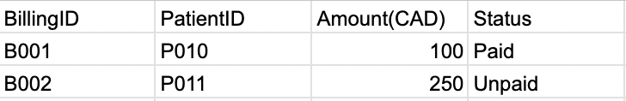
Explanation: The payment status in the Billing Table was standardised by capitalising "Paid," and the amount field was converted to CAD. This consistency in formatting supported more accurate financial analysis and streamlined billing processes.

